Historic Huguenot Street Presents, “New Netherland Marketplace, 1645: A Living History Event”

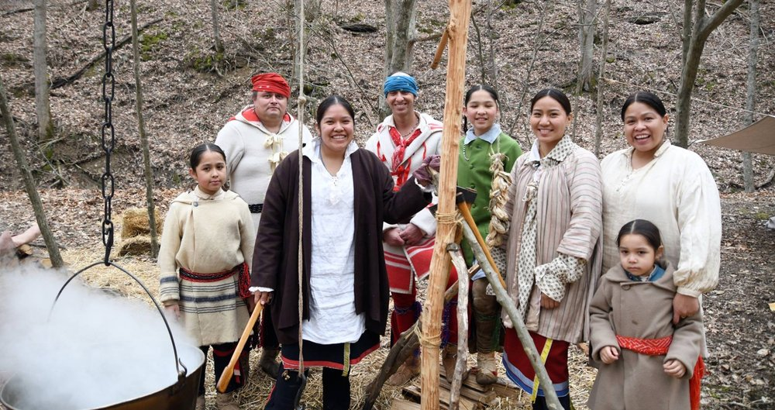

NEW PALTZ, NY (April 25, 2022) – Historic Huguenot Street is hosting a two-day living history event on Saturday, May 14 – Sunday, May 15, 2022 that will transport visitors back in time to an American colonial era marketplace. New Netherland Marketplace, 1645, pre-dates the French Protestant occupation of the region that would become known as New Paltz. Though such a setting never actually existed in this exact location, the fictional market aims to immerse visitors in a mid-17th century New Netherland, where they will discover, perhaps, a surprisingly diverse and culturally rich population comprised of Indigenous representatives, free and enslaved Africans, and Dutch artisans and merchants.
Living historians portraying Dutch merchants, traders, and craftspeople will be offering demonstrations on leather and wood working, hearth cooking, tailoring, timber framing, wampum making, and more. The marketplace will also include displays of camp gear and furs, clothing, wooden bowls, and spoons for sale. Demonstrations of cannon and musket firing will be taking place at approximately 10:30 AM and 3:30 PM on both days. Saturday’s demonstrations will include 17th century martial arts presentations at 12:00 PM and 2:00 PM.
African folktales, storytelling, and music performances will be presented by April Armstrong and Salieu Suso at 11:00 AM and 1:00 PM both Saturday and Sunday. Armstrong, who has become known for her dramatic performances of folktales from Africa, the Caribbean, and the Americas, will be accompanied by Suso on the 21-stringed kora. The kora, which originates from The Gambia in West Africa, is constructed of calabash, rosewood, cow hide, and fishing lines as strings, and most closely resembles the western harp.
Finally, Delaware and Lenape representatives will be returning to their ancestral homelands to portray the life of their ancestors and their economic relationship with the Dutch. Their camp will have ongoing open fire cooking, cordage making, bow shooting, flintknapping, arrow making, and hide tanning demonstrations throughout the weekend. Enrolled members of the Delaware Tribe of Indians (Bartlesville, OK), the Delaware Nation (Anadarko, OK), and the Delaware Nation at Moraviantown (Thamesville, Ontario) will be present, representing their people and culture, and speaking about their communities today.
This event is free and open to the public. Visitors are not required to wear a face covering while in attendance, nor are they required to show proof of COVID-19 vaccination. Appropriate face covering is neither required in the Visitor Center nor while on tours of the historic structures, though it is encouraged in order to protect our staff and community, as well as immuno-comprised and unvaccinated individuals.
On view in the Visitor Center is an exhibit of authentic artifacts associated with the Esopus Munsee people, including pottery fragments, stone tools (including arrowheads, drills, axes, scrapers, and mortar and pestle), a copper tinkle cone, and trade beads. The exhibit also features replica wampum based on the original given by the Esopus to the Dutch settlers in 1665 from the collection of the Ulster County Clerk’s Archives.
Additionally on display is an exhibit focusing on Jane Deyo Wynkoop, featuring replica archival documents that shed light on the life of one of the first African Americans to buy land in New Paltz, as well as“We wish to live with you in peace,” Hendrick Aupaumut’s Letter to the New York State Legislature.
Guided tours of the historic houses will begin at the DuBois Fort Visitor Center and be available starting at 11 AM, 11:30 AM, 12 PM, 3 PM, and 3:30 PM. Individuals may register in advance or upon arrival. Tours last approximately one hour and guide visitors to the Esopus Munsee wigwam, the European community’s original burying ground, into the reproduction 1717 French Church, and through the Jean Hasbrouck House. General admission for tours is $12. Discounts are available for HHS members, seniors, students, active military members, veterans, and children. Please see our website for more details.
For a full list of scheduled events, please visit https://www.huguenotstreet.org/new-netherland-marketplace-1645

Event partners include Wild Hudson Valley and Hampton Inn by Hilton New Paltz.
This program received significant funding through support provided by Rob D. Nagel, in recognition of the excellent Indigenous programs at Historic Huguenot Street.
This program is made possible by the New York State Council on the Arts with the support of the Governor and the New York State Legislature.
This program is funded in part by a Humanities New York SHARP Grant with support from the National Endowment for the Humanities and the federal American Rescue Plan Act. Any views, findings, conclusions or recommendations expressed in this program do not necessarily represent those of the National Endowment for the Humanities.
Image detail: Indigenous Delaware descendants at their Maple Sugar camp, March 2019. Photo provided by Jeremy Turner.

About Historic Huguenot Street
A National Historic Landmark District, Historic Huguenot Street is a 501(c)3 non-profit that encompasses 30 buildings across 10 acres comprising the heart of the original 1678 New Paltz settlement, including seven stone houses dating to the early eighteenth century. Historic Huguenot Street was founded in 1894 as the Huguenot Patriotic, Historical, and Monumental Society to preserve the nationally acclaimed collection of stone houses. Since then, Historic Huguenot Street has grown into an innovative museum, chartered as an educational corporation by the University of the State of New York Department of Education that is dedicated to preserving a unique Hudson Valley Huguenot settlement and engaging diverse audiences in the exploration of America's multicultural past in order to understand the historical forces that have shaped America.
###
Sarah Levy
Marketing & Communications Coordinator
sarahlevy@huguenotstreet.org
(845) 255-1660 Ext. 102

